Separate Compilation

Separate compilation (Fig. 2) of program modules means that modules may be complied separately and subsequently integrated to form a complete program. The integration process is carried out by another software tool known as a linker or link editor. Without the facility of separate complication, a programming language should not be considered as viable languages for software engineering.

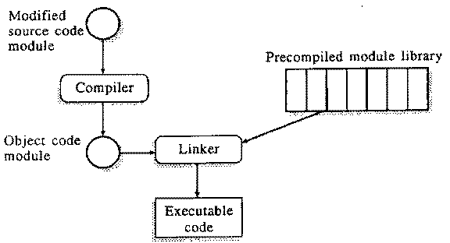

Separate Compilation

A large program may consist of several thousand lines of source code and it may take hours or even days to compile the complete program. If every program module needed to be recompiled each one of the module was changed, this would impose significant overhead and increase the costs of program development debugging and maintenance. If separate compilation is available is, compiling the whole system is necessary. Only the modified modules need be recompiled and the system re-linked.

The strategy used by **Java** is called ***separate compilation***, which means that when the compiler encounters an external reference, it automatically attempts to resolve it.

A separate compilation facility is vital for the development of large systems and this is one of the principal reasons why **FORTRAN**, in spite of its shortcoming ,has been so widely used in software engineering projects the design of the **FORTRAN** routines can be developed.